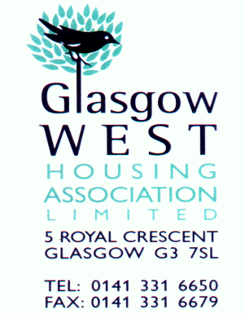
MEMBERSHIP APPLICATION FORM

I wish to become a member of Glasgow West Housing Association Limited (GWHA) and I enclose £1.00 for my Share Certificate

I am over 16 years of age

Name |  |  | Title | Mr/Mrs/Miss/Ms
Address |  |  | Flat No |  | Tel
 |  |  | Postcode |  | Mob
Date of Birth |  |  | Age |  | Email
Occupation/Profession
Current Employer
Please tick which category applies to you

A. Tenant of the Association
B. Owner receiving a factoring service from GWHA
B. Other residents in GWHA area of operation
C. Others
(You will be required to attend an interview with the Membership Panel. The panel must be satisfied that your reasons for applying are consistent with the objectives of GWHA membership Policy)
Are you or have you ever been a member of another Housing Association? Yes No
If yes please state which one:-

Are you related to any staff member or committee member of GWHA? Yes No
If yes, who:-

Have you ever been employed by GWHA. If so, when? Yes No

Why do you wish to join GWHA?

Are you interested in finding out more about GWHA? Yes No

Would you be interested in becoming a member of the Management Committee? Yes No
Please tick which method of communication is your preference.
Email Letter Fax Text Other

Other relevant information:

Signature………………………………………………… Date…………………………

Please ensure all sections are completed and return form to: Glasgow West Housing Association Limited, 5 Royal Crescent, Glasgow, G3 7SL with your £1.00.

OFFICIAL USE ONLY
Source of application
Sign up/AGM/ATC/other
Cat A Verified by

Cat B Verified by

Registered with the Scottish Housing Regulator HEP 126. Registered under the Co-operative and Community Benefit Societies Act (2014) 1955 RS. Registered as a Scottish Charity SC001667

