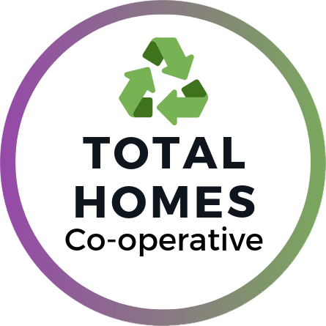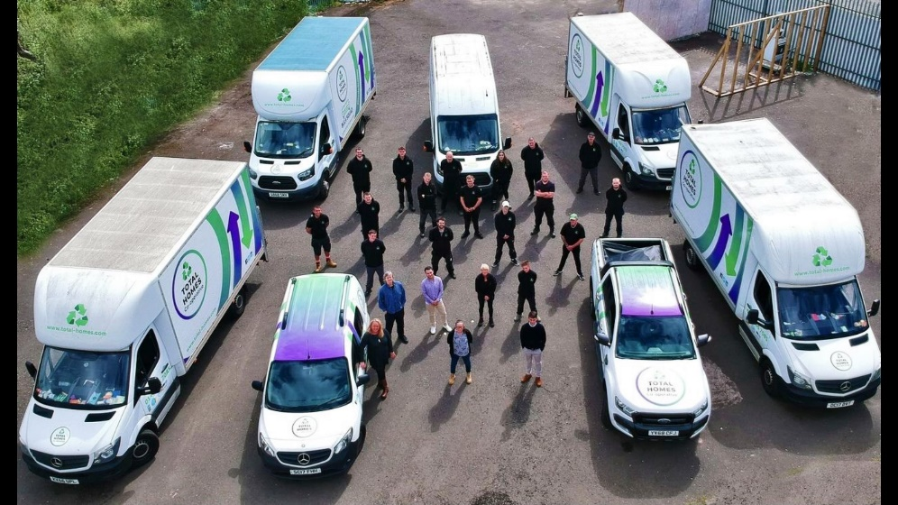

FLY TIPPING & BULK WASTE: Let’s make a difference!
We need your help!

If you have any household bulk items to dispose of Total Homes can collect it from your door.
Please contact Total Homes direct on 0141 556 7085, or email bulk@total-homes.com to confirm items requiring uplift. You will be given a collection reference number and any additional information relating to the uplift at that time, typically within 48hrs.

Glasgow West Enterprise Property Factor customers must then call our main switchboard on 0141 331 6650 and leave a message confirm you wish to make advance payment for the collection. You will receive a call back from one of our Finance Officers that day, after which the Total Homes uplift will be approved by our Estates Team.
Fly tipping will be risk reviewed and removed on a case by case basis with recharges applied retrospectively in line with routine factoring invoices.

How did we get here?
Following our resident consultation process around the issues faced by the withdrawal of the Glasgow City Council Bulky Waste collection service we are pleased to confirm that we will be working in partnership with Total Homes to address fly tipping issues, and to pilot a sustainable bulk waste management service to help improve our neighbourhoods. Over the coming months this will include:
- Adopting and promoting Recover, Reduce, Repair, Reuse, and Recycling principles,
- Items being collected and sorted rather than going direct to landfill,
- Exploring the operational challenges of implementing this service,
- Developing our frontline process and procedures,
- Promotion and guidance through social media, newsletters,

For more information on Total Homes please check out their website (www.total-homes.com)
For details of the Glasgow City Council on-demand service please check www.glasgow.gov.uk/bulkywaste for guidance and service updates.

Additional information can be found here:

http://www.gwha.org.uk/housing/news/?id=721&title=Glasgow-City-Council-%28GCC%29-Bulk-Waste-Uplift-Charges

http://www.gwha.org.uk/gwen/news/?id=722&title=Glasgow-City-Council-%28GCC%29-Bulk-Waste-Uplift-Charges

